Type of Analysis:

Simple Mediation with a Categorical X (Model 4)

Model Visualization:

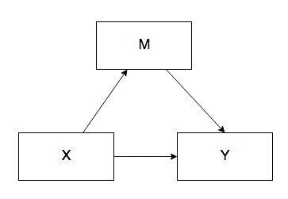

Stacked for each categorical combination.

IVs:

* Cylinders (X)
* Weight (M)

DV:

* Miles Per Gallon

Power:

Figure out X (4,6,8 as our categories)

X1 4 versus 6

X2 4 versus 8

M

Total: 3 predictors

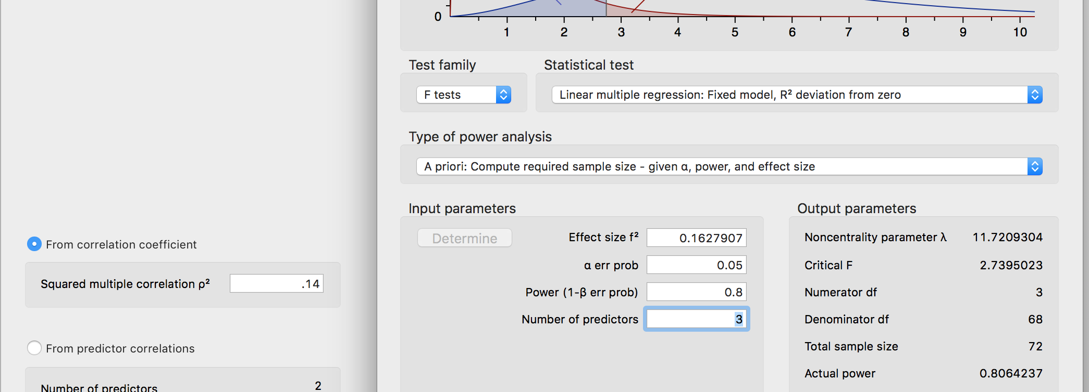

Data Screening:

* Accurate Data

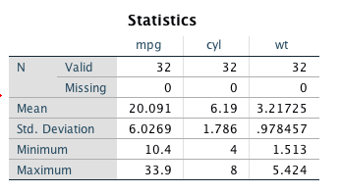

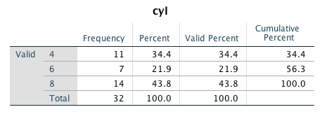

* Missing Data

None see above.

* Outliers
  + Mahalanobis
    - DF: number of variables in the equation (just M because X is categorical so we left it out) = 1
    - Cut off is 10.83
  + Cooks
    - 4/(N – k – 1) k is the number of predictors
    - 4/30 = .1333
  + Leverage
    - (2K + 2)/N
    - 4/32 = .125
  + One outlier found but didn’t exclude.
* Assumptions:
  + Additivity did not run because we cannot do X by M with categories.
  + Normality

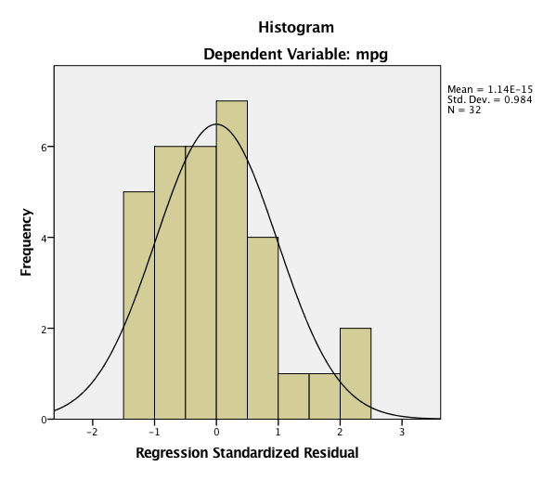

* + Linearity

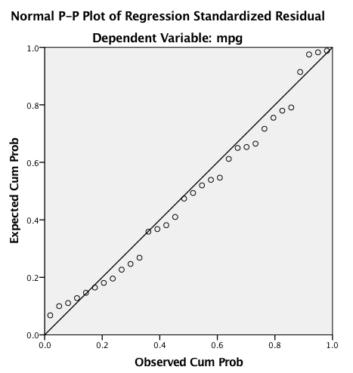

* + Homogeneity/Homoscedasticity

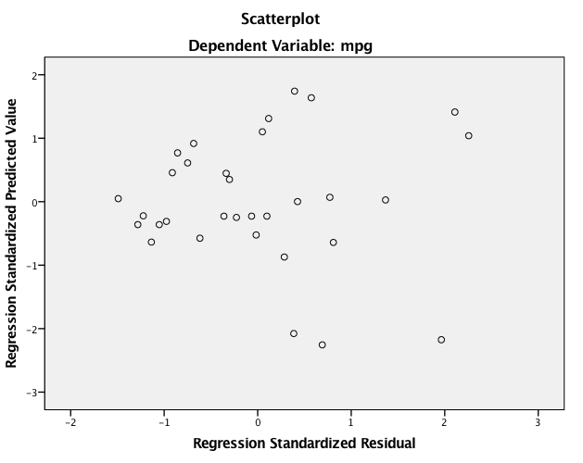

Analysis:

\*\*\*\*\*\*\*\*\*\*\*\*\*\*\*\* PROCESS Procedure for SPSS Version 3.00 \*\*\*\*\*\*\*\*\*\*\*\*\*\*\*\*\*  
  
          Written by Andrew F. Hayes, Ph.D.       www.afhayes.com  
    Documentation available in Hayes (2018). www.guilford.com/p/hayes3  
  
\*\*\*\*\*\*\*\*\*\*\*\*\*\*\*\*\*\*\*\*\*\*\*\*\*\*\*\*\*\*\*\*\*\*\*\*\*\*\*\*\*\*\*\*\*\*\*\*\*\*\*\*\*\*\*\*\*\*\*\*\*\*\*\*\*\*\*\*\*\*\*\*\*\*  
Model  : 4  
    Y  : mpg  
    X  : cyl  
    M  : wt  
  
Sample  
Size:  32  
  
Coding of categorical X variable for analysis:  
    cyl     X1     X2  
  4.000   .000   .000  
  6.000  1.000   .000  
  8.000   .000  1.000  
  
\*\*\*\*\*\*\*\*\*\*\*\*\*\*\*\*\*\*\*\*\*\*\*\*\*\*\*\*\*\*\*\*\*\*\*\*\*\*\*\*\*\*\*\*\*\*\*\*\*\*\*\*\*\*\*\*\*\*\*\*\*\*\*\*\*\*\*\*\*\*\*\*\*\*  
OUTCOME VARIABLE:  
 wt  
  
Model Summary  
          R       R-sq        MSE          F        df1        df2          p  
      .7826      .6124      .3967    22.9114     2.0000    29.0000      .0000  
  
Model  
              coeff         se          t          p       LLCI       ULCI  
constant     2.2857      .1899    12.0369      .0000     1.8973     2.6741  
X1            .8314      .3045     2.7304      .0106      .2086     1.4542  
X2           1.7135      .2538     6.7525      .0000     1.1945     2.2325

Path a(s)

X1 4v6 *b* = 0.83, *t*(29) = 2.73, *p* = .011 -> diff in wt for 4 and 6 cars

X2 4v8 *b* = 1.71, *t*(29) = 6.75, *p* < .001 -> diff in wt for 4 and 8 cars

Use split file to look at the means for each group, report means

\*\*\*\*\*\*\*\*\*\*\*\*\*\*\*\*\*\*\*\*\*\*\*\*\*\*\*\*\*\*\*\*\*\*\*\*\*\*\*\*\*\*\*\*\*\*\*\*\*\*\*\*\*\*\*\*\*\*\*\*\*\*\*\*\*\*\*\*\*\*\*\*\*\*  
OUTCOME VARIABLE:  
 mpg  
  
Model Summary  
          R       R-sq        MSE          F        df1        df2          p  
      .9151      .8374     6.5378    48.0787     3.0000    28.0000      .0000  
  
Model  
              coeff         se          t          p       LLCI       ULCI  
constant    33.9908     1.8878    18.0056      .0000    30.1237    37.8579  
X1          -4.2556     1.3861    -3.0702      .0047    -7.0949    -1.4163  
X2          -6.0709     1.6523    -3.6742      .0010    -9.4555    -2.6862  
wt          -3.2056      .7539    -4.2521      .0002    -4.7499    -1.6613

Path b:

Wt -> MPG M -> Y *b* = -3.21, *t*(28) = -4.25, *p* < .001: as weight goes up, mpg goes down

Path c’:

X1 *b* = -4.26, *t*(28) = -3.07, *p* = .005: difference in mpg for 4 and 6

X2 *b* = -6.07, *t*(28) = -3.67, *p* = .001: difference in mpg for 4 and 8

\*\*\*\*\*\*\*\*\*\*\*\*\*\*\*\*\*\*\*\*\*\*\*\*\*\* TOTAL EFFECT MODEL \*\*\*\*\*\*\*\*\*\*\*\*\*\*\*\*\*\*\*\*\*\*\*\*\*\*\*\*  
OUTCOME VARIABLE:  
 mpg  
  
Model Summary  
          R       R-sq        MSE          F        df1        df2          p  
      .8558      .7325    10.3884    39.6975     2.0000    29.0000      .0000  
  
Model  
              coeff         se          t          p       LLCI       ULCI  
constant    26.6636      .9718    27.4373      .0000    24.6760    28.6512  
X1          -6.9208     1.5583    -4.4411      .0001   -10.1080    -3.7335  
X2         -11.5636     1.2986    -8.9045      .0000   -14.2197    -8.9076

Path c:

X1 *b* = -6.92, *t*(29) = -4.44, *p* < .001: difference in mpg for 4 and 6

X2 *b* = -11.56, *t*(29) = -8.90, *p* < .001: difference in mpg for 4 and 8

\*\*\*\*\*\*\*\*\*\*\*\*\*\* TOTAL, DIRECT, AND INDIRECT EFFECTS OF X ON Y \*\*\*\*\*\*\*\*\*\*\*\*\*\*  
  
Relative total effects of X on Y:  
       Effect         se          t          p       LLCI       ULCI  
X1    -6.9208     1.5583    -4.4411      .0001   -10.1080    -3.7335  
X2   -11.5636     1.2986    -8.9045      .0000   -14.2197    -8.9076  
  
Omnibus test of total effect of X on Y:  
    R2-chng          F        df1        df2          p  
      .7325    39.6975     2.0000    29.0000      .0000  
----------  
  
Relative direct effects of X on Y  
       Effect         se          t          p       LLCI       ULCI  
X1    -4.2556     1.3861    -3.0702      .0047    -7.0949    -1.4163  
X2    -6.0709     1.6523    -3.6742      .0010    -9.4555    -2.6862  
  
Omnibus test of direct effect of X on Y:  
    R2-chng          F        df1        df2          p  
      .0846     7.2856     2.0000    28.0000      .0028  
----------  
  
Relative indirect effects of X on Y  
  
 cyl         ->    wt          ->    mpg  
  
       Effect     BootSE   BootLLCI   BootULCI  
X1    -2.6652      .9767    -4.8801    -1.0561  
X2    -5.4928     1.4045    -8.5184    -3.0180

X1 indirect = -2.67, *SE* = .98, 95% CI[-4.88, -1.06]: since does not include zero, would say mediation has occurred for 4vs6

X2 indirect = -5.49, *SE* = 1.40, 95% CI[-8.51, -3.01]: since does not include zero, would say mediation has occurred for 4vs8  
  
\*\*\*\*\*\*\*\*\*\*\*\*\*\*\*\*\*\*\*\*\*\*\* ANALYSIS NOTES AND ERRORS \*\*\*\*\*\*\*\*\*\*\*\*\*\*\*\*\*\*\*\*\*\*\*\*  
  
Level of confidence for all confidence intervals in output:  
  95.0000  
  
Number of bootstrap samples for percentile bootstrap confidence intervals:  
  5000  
  
NOTE: Due to estimation problems, some bootstrap samples had to be replaced.  
      The number of times this happened was:  
        3  
  
------ END MATRIX -----

Quantpsy.org

First path:

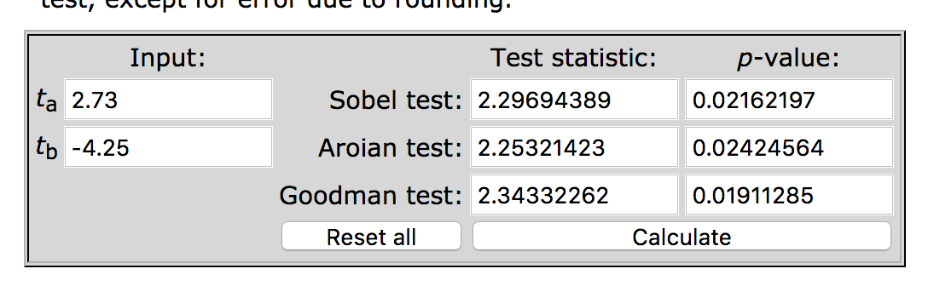

Second path:

